Test Case 1:

Test Case 2:

Test Case 4:

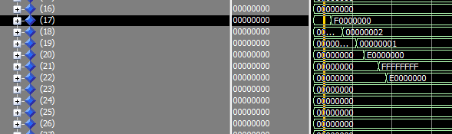

Test Case 7:

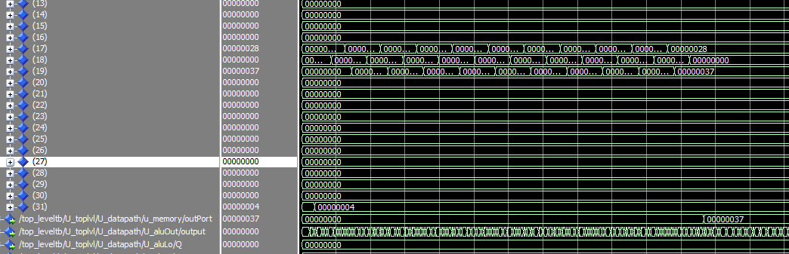

GCD:

Bubble Sort: